Lunchtime Reading Group

ʿAmmār al-Baṣrī’s Kitāb al-burhān (The Book of Proof)

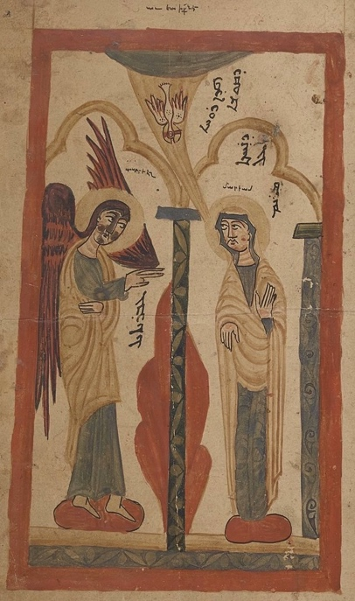

**Time: Thursdays, TT25 Weeks 1-8, 12:30-2:00pm**

**Location: Small Meeting Room, Faculty of Theology and Religion, 2nd Floor** [**Gibson Building**](https://maps.app.goo.gl/GNAGmVsQ9XKn311Q6) **OX2 6GG**

ʿAmmār al-Baṣrī (d.c. 850 CE) was an East Syrian theologian and apologist who wrote the first Christian systematic theology in Arabic, in dialogue with Muslim thinkers of his time. During the term, we will read three sections with relevance to political theology from his work *Kitāb al-Burhān,* amounting to about 4 pages of Arabic text each week*:*

1. *dalāʾil ʿalā l-dīn al-haqq* (Proofs of the True Religion)
2. *asbāb qubūl al-naṣrāniyya* (Reasons for the Acceptance of Christianity)
3. *ithbāt al-tajassud* (Confirmation of the Incarnation)

For a short introduction to the work, see M. Beaumont “[ʿAmmār al-Baṣrī: Defending the Incarnation of the Son of God](https://solo.bodleian.ox.ac.uk/permalink/44OXF_INST/ao2p7t/cdi_walterdegruyter_books_10_31826_9781463244484_012)” in *Medieval Encounters,* ed. M. Beaumont and A. Ibrahim, Piscataway NJ, 2022. For a longer introduction to the thought of ʿAmmār al-Baṣrī , see M. Beamont, [*The Theology of ʿAmmār al-Baṣrī*](https://solo.bodleian.ox.ac.uk/permalink/44OXF_INST/35n82s/alma991026787192707026) , Piscataway NJ, 2021. An English translation of the work is also available to consult in M. Beamont [*ʿAmmār al-Baṣrī’s Arabic Apologetic Works*](https://solo.bodleian.ox.ac.uk/permalink/44OXF_INST/35n82s/alma991026786960907026)*,* Piscataway NJ, 2022

The Annunciation (Nestorian Evangelion MS syr. 344)

The Arabic text we will be reading from can be found in M. Hayek, [*ʿAmmār al-Baṣrī: Apologie et Controverses*](https://solo.bodleian.ox.ac.uk/permalink/44OXF_INST/35n82s/alma990151250920107026), Beirut, 1977. The excerpts for the reading group are available [here.](https://unioxfordnexus-my.sharepoint.com/:f:/g/personal/lady5053_ox_ac_uk/Ej89hzLQiV9HnPc_DUm6GlIBJYG6djlmOrPn1xImZ9tvOw?e=UXCJet) No preparation is required, though you may find it helpful to read the excerpts ahead of meetings. You may also wish to bring a copy of a classical Arabic dictionary for easy reference.

## Reading Schedule

|  |  |  |  |
| --- | --- | --- | --- |
| W1 | *dalāʾil ʿalā l-dīn al-haqq,* pt. 1  (pp. 24b – 27a) | W5 | *ithbāt al-tajassud,* pt. 1 (pp. 62b – 67a) |
| W2 | *dalāʾil ʿalā l-dīn al-haqq,* pt. 2  (pp. 27b-32a) | W6 | *ithbāt al-tajassud,* pt. 2 (pp. 67b – 71a) |
| W3 | *asbāb qubūl al-naṣrāniyya,* pt. 1  (pp. 32b-36a) | W7 | *ithbāt al-tajassud,* pt. 3 (pp. 71b – 75a) |
| W4 | *asbāb qubūl al-naṣrāniyya,* pt. 2  (pp. 36b – 41a) | W8 | *ithbāt al-tajassud,* p. 4 (pp. 75b – 79a) |

Contact Dr Steven Firmin at [iicptnetwork.ox.ac.uk](mailto:iicptnetwork.ox.ac.uk) for more information.